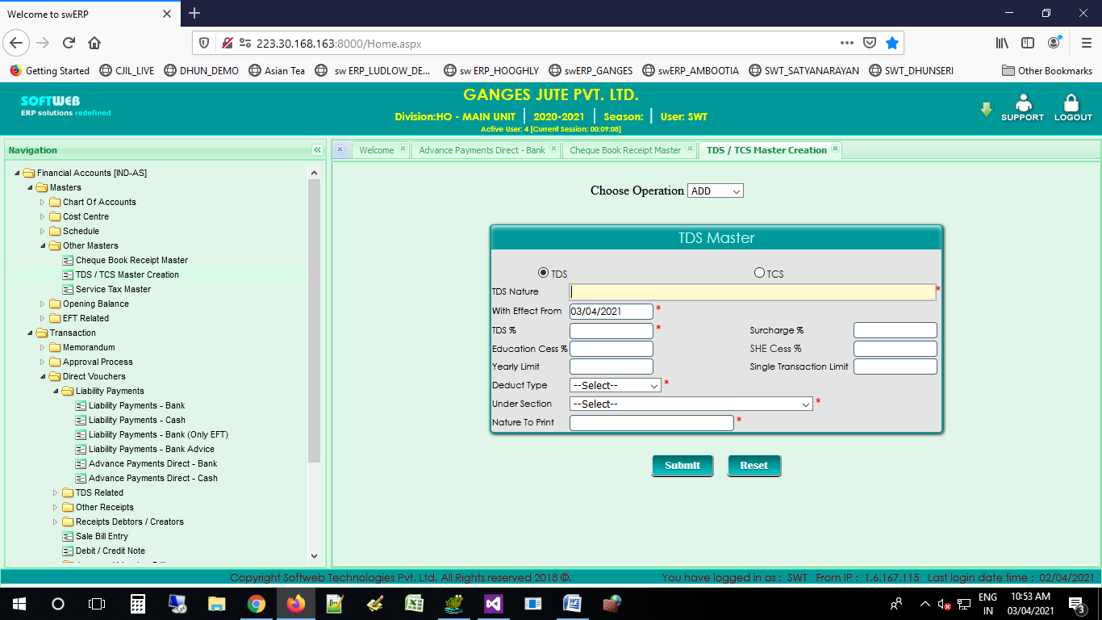

1. DATA NOT FETCHED

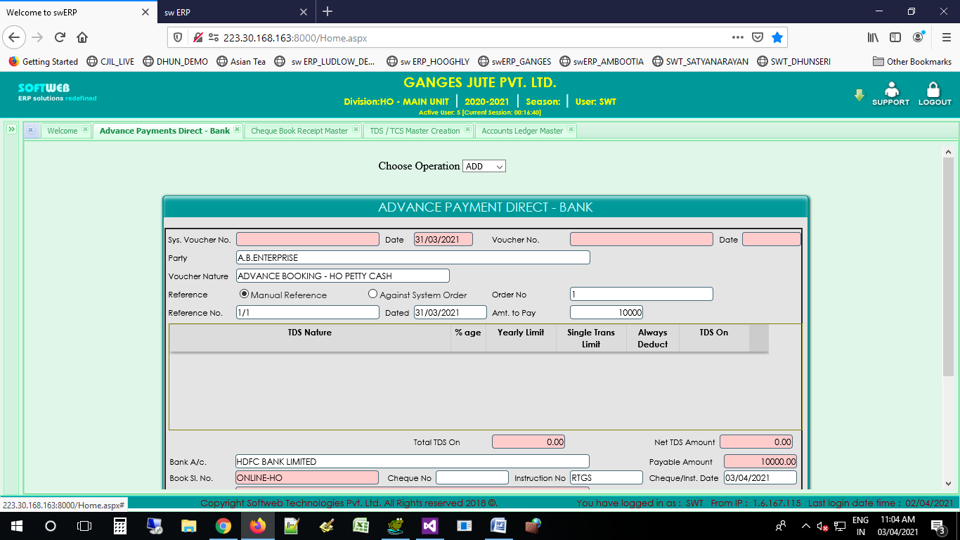

COPY FROM TEA

“NONE” IN VOUCHERNO SHOULD APPEAR IN LOV